# Laravel 11 Developer Test Task Instructions

**Task:** Recreate the **donation widget** seen on [Donate button widget](https://www.nightbright.org/find/night-bright) with test Stripe credentials using connected accounts. The donation should end on the Stripe payment link.

Step 1:  
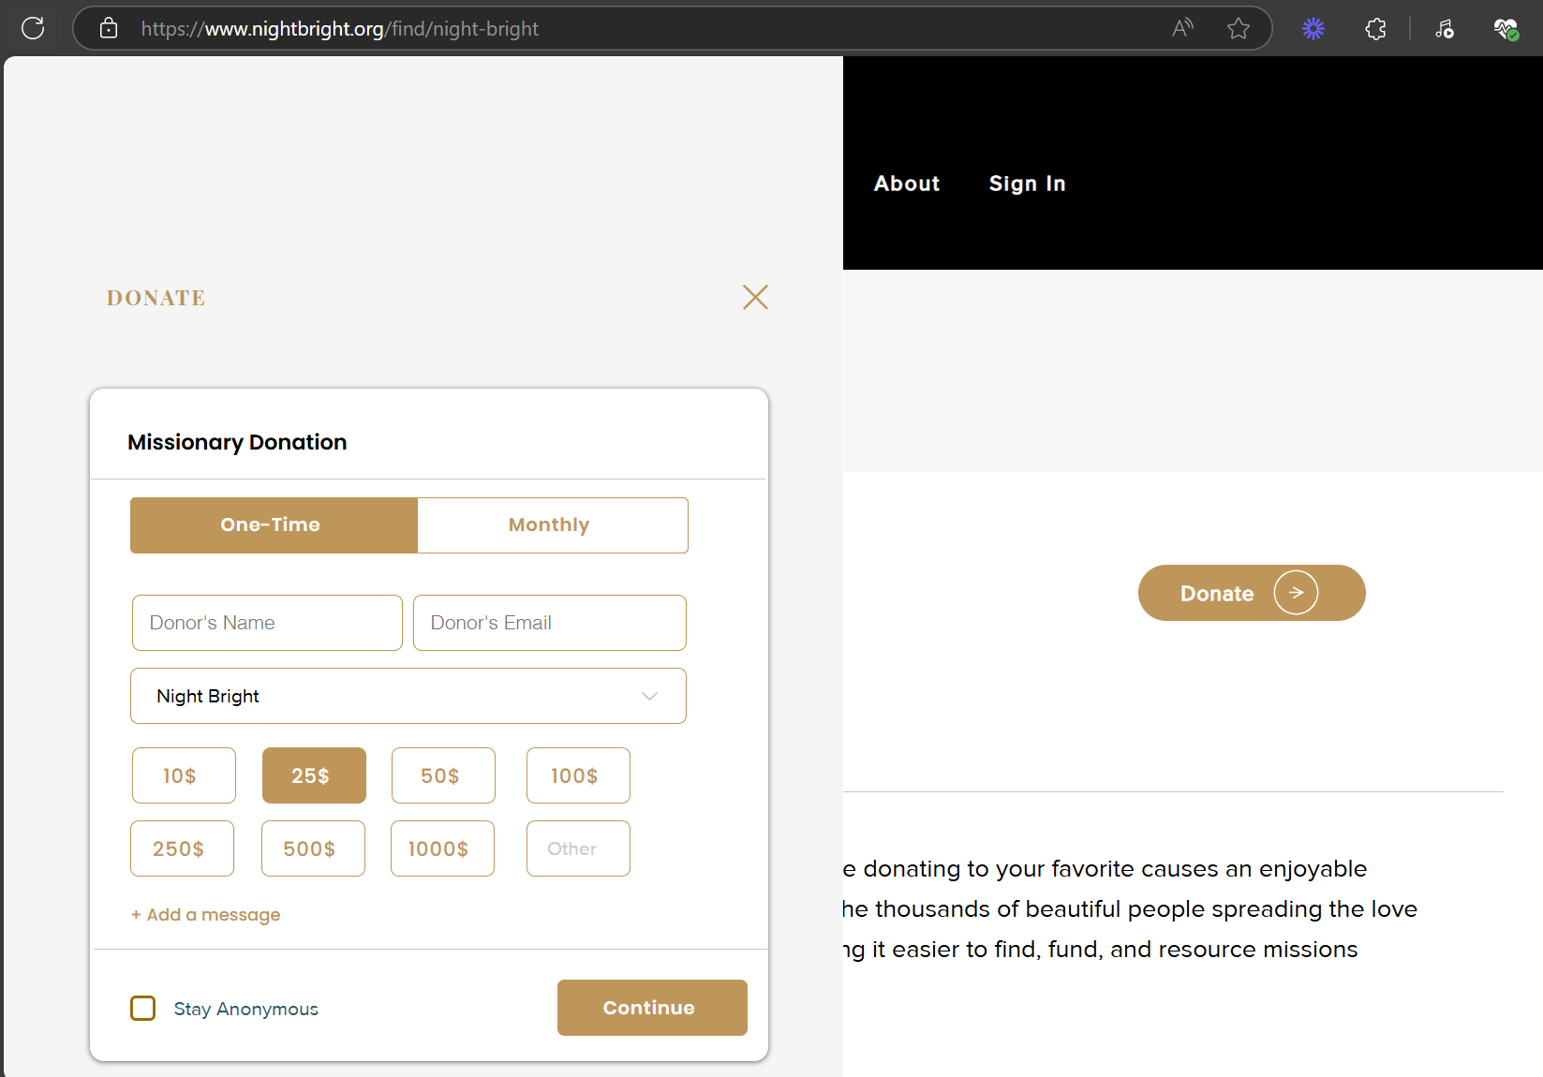

Step 2:

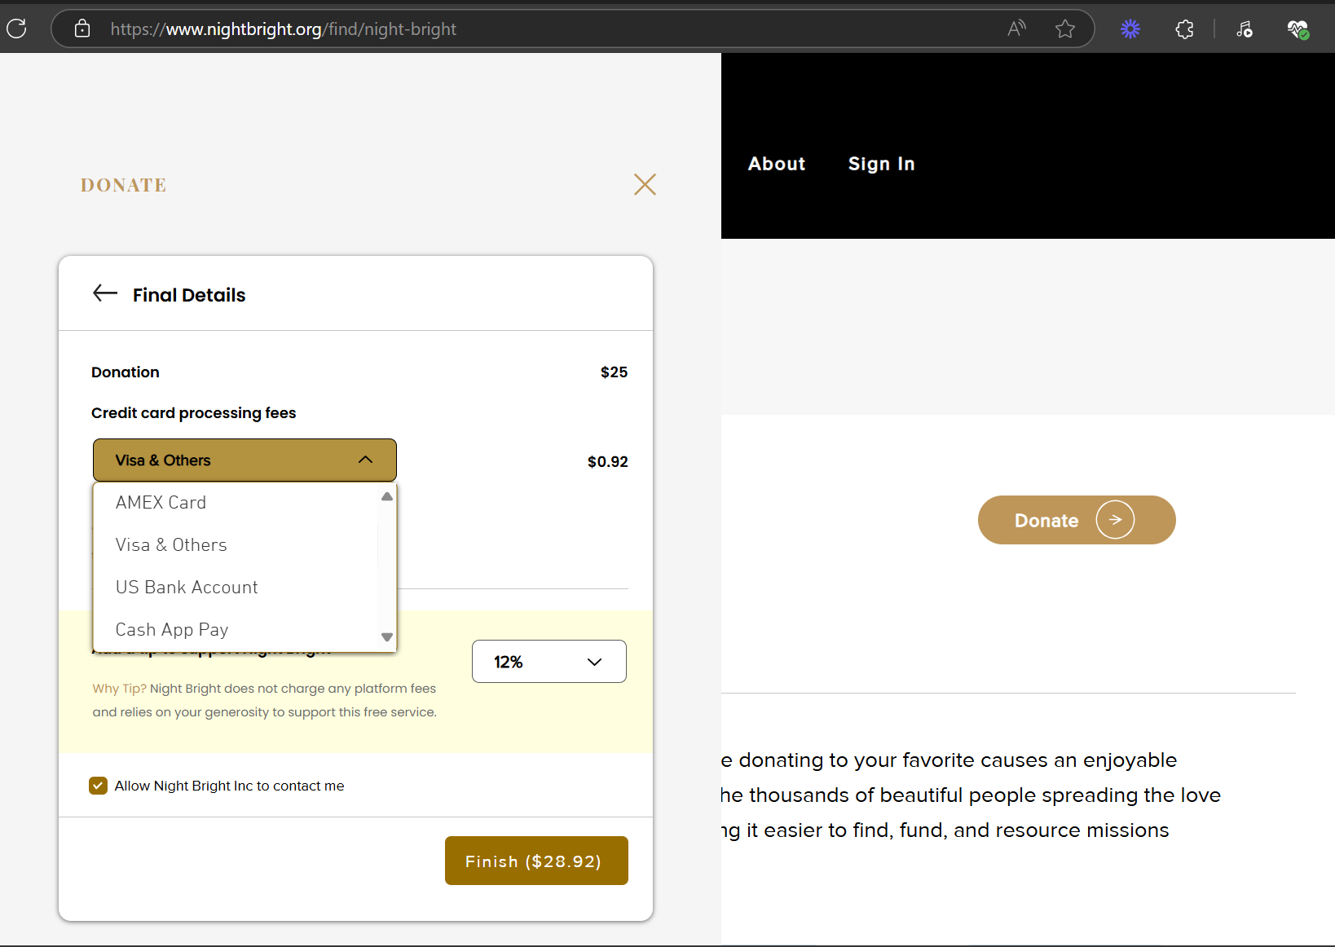

Step 3: Loading screen

Step 4: Stripe payment page

## Requirements

✅ Use **Laravel 11**   
✅ Ensure **pixel-perfect implementation** (must match the original design exactly)   
✅ Recreate **both steps** of the widget flow   
✅ Maintain responsive behavior (desktop + mobile)   
✅ Include all relevant button states, error handling, and input validation

## Deliverables

1. Upload the working Laravel 11 project to a public link.
2. Provide a **link to the live demo** for review.
3. Include a short **README.md** with:
   * Setup instructions
   * Any assumptions you made

## Evaluation Criteria

* Code quality (clear, organized, reusable)
* Pixel-perfect accuracy
* Functional correctness
* Responsive design
* README clarity

**Deadline:** Please complete and submit the link within the agreed timeframe.